SEQUENCE DIAGRAM SPECIFICATION

ONLINE CLOTHING STORE SYSTEM
Online Clothing Store
DGM-02
The message exchange sequence among Customer, Web App, Payment Gateway, and Database during the Place Order process.
Version 1.0
September 30, 2026
UEF SHOP

Sequence Diagram Specification
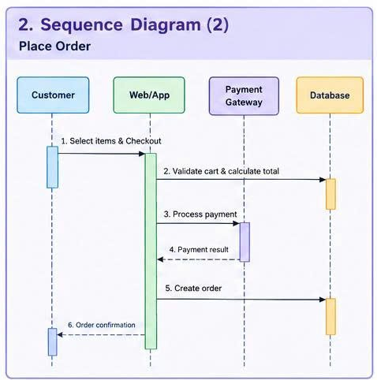
Figure 1. Sequence Diagram for the Online Clothing Store system

Scenario Information
Code | SD-01 Place Order
Objective | Describe the order of exchanges among Customer, Web/App, Payment Gateway, and Database when an order is placed.
Preconditions | The Customer has a valid cart and has supplied the required checkout information.
Postconditions | The order is saved and the Customer receives confirmation; on failure, no duplicate or invalid order is created.
Related Use Case | UC-06 Checkout

Participants
Lifeline | Responsibility
Customer | Initiates checkout and receives the order result.
Web/App | Coordinates the process, validates data, and returns UI feedback.
Payment Gateway | Processes or confirms the payment transaction.
Database | Reads cart and inventory data; writes Order, OrderItem, and Payment records; and updates stock.

Message Sequence
Step | Source -> Destination | Message | Processing and Data
1 | Customer → Web/App | Select items and Checkout | Send cartId, address, delivery method, and payment method.
2 | Web/App → Database | Validate cart and calculate total | Validate products, current prices, and stock; return the authoritative total.
3 | Web/App → Payment Gateway | Process payment | Send the order token, amount, method, and idempotency key.
4 | Payment Gateway → Web/App | Payment result | Return success or failed status with the transaction identifier.
5 | Web/App → Database | Create order | Write Order, OrderItem, and Payment records and reduce inventory in one database transaction.
6 | Web/App → Customer | Order confirmation | Display the order number, total amount, and initial status.

Alternative Flows and Error Handling
Code | Condition | System Response
ALT-01 | Empty cart, hidden product, or insufficient stock | Stop before step 3 and return a list of errors so the Customer can correct the cart.
ALT-02 | Payment Gateway declines the transaction | Do not perform step 5; display an error and allow another method to be selected.
ALT-03 | Payment Gateway timeout | Query transaction status by idempotency key before resubmitting.
ALT-04 | Database write fails after payment | Roll back the data and create a refund request or reconciliation queue entry.
ALT-05 | Customer submits a duplicate request | Return the result of the first request without creating a second Order.

Sequence Constraints
The Web/App must recalculate the total from trusted data rather than accept a total supplied by the browser. Create order occurs only after a successful Payment result. Order, OrderItem, Payment, and inventory updates must be written in one transaction or use a clearly defined compensation mechanism. The confirmation notice is always the final step after the Database confirms successful persistence.

